Title: An Exploratory Analysis to Assess reproducibility of COVID-19 bulk RNA-seq Datasets
Authors: Geordan Bolden, M.S. , Dr. Cristina Mitrea
Abstract
Integrating public transcriptomic datasets can significantly increase statistical power, yet technical batch effects and biological heterogeneity frequently compromise downstream meta-analyses. In this study, we evaluated the requirements, limitations, and cross-dataset reproducibility of integrated bulk RNA-seq workflows using five publicly available COVID-19 datasets. Utilizing the ComBat-Seq algorithm alongside principal variance component analysis (PVCA), we demonstrated that while technical batch effects from sequencing platforms and baseline depths were successfully minimized, the post-correction landscape resolved into two distinct macro-clusters. This persistent divergence cuts across tissue types and sequencing platforms, indicating fundamental differences in experimental design or clinical disease stages rather than technical artifacts. Differential expression and over-representation analyses (ORA) revealed zero universally shared differentially expressed genes (DEGs) across all five datasets, though a robust consensus core of 60 DEGs and 15 ORA terms tied to cell-cycle suppression was identified. When restricting analysis tightly to identical clinical contrasts (Healthy vs. COVID-19), we identified a conserved downregulation of B-cell-mediated immunity markers (IGHG1, IGHG3). Our findings demonstrate that robust batch-correction algorithms are necessary but insufficient to reconcile deep-seated discrepancies in sample composition and clinical phenotypic phases. Consequently, establishing reproducible biomarkers requires future meta-analyses to strictly harmonize clinical contrast specificity and capture the continuous biological gradients inherent to heterogeneous cohorts.
Introduction
Bulk RNA-Seq technologies allow the dissection into the transcriptome of biological systems. This has enabled researchers to measure and compare the mRNA output of injuries, disease states, and drug responses. However, due to financial constraints, cohort coordination, and sample acquisition difficulties this can produce dimensionally inefficient data, little number of samples per condition paired with many surveyed features, with a low number of biological replicates, paired with technical variations have led to different results within downstream analysis despite similar study designs and identical disease states. This could include different number of DEGs overlap between datasets, different over-represented terms, or gene set enrichment results. In the Cui et. al., study, the authors compared numerous RNA-seq datasets sampled under different oncological states with a range of biological replicates from the TCGA database. Cui et. al. not only found an almost direct relationship between the number of biological samples and the total number of differentially expressed genes (DEGs) but also found disease-based heterogeneity of those DEGs between the datasets.
Batch effects are unwanted technical variations within a bulk RNA-Seq dataset that can reduce the biological signal and statistical power of a study and has been a source of irreproducibility and incorrect conclusions within other’s research. An example of batch effect within a dataset would be a confounding variable within a cohort’s collection (lack of randomized collection), or sample preparation (reagent change during RNA collection) (Yu. Y, Genome Biol, 2024). When performing dimensionality reduction (PCA, UMAP, etc.) these effects can appear when the clusters are not grouping by a non-relevant covariate within the study. For example, if you are expecting the scaled sample loadings to cluster by condition but are clustered by batch then we are seeing clear change of practice between samples and have introduced unnecessary technical variation.
For this report I would like to present my findings for Project 1 of the University of Michigan BIDS Hackathon 2026, hosted by faculty within the Department of Computational Biology and Bioinformatics. The objective of Project 1 was to compare the DEGs overlap between COVID-19 data sets, assess potential internal batch effects, perform batch correction, and find what can contribute to batch effects within integrated datasets.
Methods
Preprocessing
Each dataset was downloaded via GEOaccession (table 1) then preprocessed using tidyverse packages on R and made suitable for a Deseq2 Dataset (DDS) and the suite of QC functions available within the RNAseqQC library. Preprocessing to achieve this point would include basic data wrangling to obtain consistent naming and form between datasets so that they can be integrated using Combat-Seq batch correction algorithm, and summarizing genes between samples. Preprocessing did not include filtering for low count genes, but did include the exclusion of samples the authors deemed to have “poor data quality”. Each dataset and their respective metadata were then loaded into a DeseqDataset object, the raw counts were then log normalized for comparable counts across samples within a dataset. The raw counts were also variance stabilized using the DESeq2’s vst() function. The resulting matrices were saved into individual assay slots within the DDS object for further analysis.
Dataset # | GSE Acc. | Platform | Tissue | Disease States | Sample Breakdown | Design Type | Total Samples
DS1 | GSE202805 | Illumina HiSeq 4000 | PBMC | Healthy  Acute Covid 19  Convalescent | Healthy Ctrls = 10  Acute Mild. Covid19 = 4  Acute Moderate = 4  Acute severe = 32  Convalescent = 28 | Cross-sectional observational case-control | 80
DS2 | GSE152641 | Illumina NovaSeq 6000 | Whole Blood | Healthy  Acute Covid 19 | Healthy = 24  Acute Covid 19 = 62 | Prospective observational case-control | 86
DS3 | GSE161731 | Illumina NovaSeq 6000 | Whole Blood | Healthy  CoV Other  Influenza  Bacterial  COVID-19 | Healthy = 19  Influenza = 17  CoV Other = 59  COVID-19 = 77  Bacterial = 23 | Mixed-Cross Sectional+ Longitudinal | 198
DS4 | GSE227116 | Illumina HisSeq 2500 | Whole Blood | Healthy  Convalescent | Healthy = 10  Convalesent = 46 | Longitudinal | 56
DS5 | GSE152418 | Illumina NovaSeq 6000 | PBMC | Healthy  Acute Covid-19 | 17 COVID-19 subjects and 17 healthy controls | Cross-sectional case-control substudy | 34

Table 2: Possible 1v1 Comparison Overlaps
Possible 1v1 Combinations of all Datasets (Datasets that support that specific contrast*)
Healthy-Conv
(GSE202805, GSE227116 )
Healthy – covid19  (GSE202805, GSE227116 ,  GSE161731,  GSE152641 ) | Conv – covid19  GSE202805
Healthy – bacterial  GSE161731 | Conv – bacterial  Integrated DS | Covid19 – bacterial  GSE161731
Healthy – cov_other  GSE161731 | Conv – cov_other  Integrated DS | Covid19 – cov_other  GSE161731 | Bacterial – cov_other  GSE161731
Healthy - Influenza  GSE161731 | Conv – Influenza  Integrated DS | Covid19 –  Influenza  GSE161731 | Bacterial – influenza  GSE161731 | Cov_other – influenza  GSE161731

Quality Check and Intra Batch Effect Assessment
Using the RNAseqQC functions, I was able to create library size histograms and library complexity curves to assess for sufficient sequencing depth and transcriptional diversity of each dataset. To assess internal batch effects of the dataset I performed basic dimensionality reduction techniques such as pairwise distance mapping, principal component analysis, and principal variance component analysis to measure the magnitude of variance from each covariate within the study relative to a PC’s variance. Due to compatibility constraints between the original pvca package and Deseq2 data structures, a custom implementation was developed based on the framework by Li, Bushel, et al. The function quantifies the sources of variation in the dataset by fitting a linear mixed model, treating covariates and factors of interest as random effects to partition variance across principal components (PCs). For categorical variables, an ANOVA is conducted to test the significance of the association between each covariate and the PC scores. The final output is visualized as a heatmap of pvalues, providing an estimated, color coordinated overview of which experimental or technical factors drive the variation in each PC. Once the datasets were integrated into one object and batch correction was performed these dim reduction techniques were performed again to assess the degree of variability within the data.
Integration Method
For each dataset, low count genes were excluded before concatenation. Using the cbind() function to concatenate the raw count matrices, only genes present within all datasets were included within the combined raw counts matrix. To harmonize the metadata, first condition names are standardized, each sample is tagged with their respective dataset origin, and each covariate was included to measure contribution of variance using PVCA before and after batch correction. If a sample from one dataset did not have a marked time point, or patient race, etc, where as another sample possessed those variables, then it would be marked with NA or none to included meta data. These filtered counts alongside the new meta data were made in a DDS object where the counts would be log normalized or variance stabilized for the dimension reduction described above.
DEG analysis and Over-Representation Analysis
An EdgeR (Robinson, MD., McCarthy DJ, et. al., Bioinformatics, 2009), clusterProfiler::EnrichGO (Yu G., Wang LG., et. al., OMICS, 2012) based R pipeline was built to swiftly perform differential expression analysis of each combination of comparison of conditions that exist within the metadata of a DDS object, and reported back filtered, via user specified log2FC, p.val_adj threshold, number of DEGs and the table for each comparison within the DDS object. Volcano plots and heatmap of z-scaled raw counts of the filtered DEGs per comparison are also created. This pipeline also includes Over-Representation test against the gene ontology for biological processes (GO:BP) using EnrichGO. These results are unpacked and aligned with their input DEG of interest automatically for volcano-plot and heatmap display of DEGs within that over-represented term. The terms would be ranked by statistical significance (p.val_adj) or gene count the displayed via dotplot. These would be used to decided which OR terms’ DEGs could be shown on the heatmap using my custom heatmap function. This helped streamline the downstream analysis of the datasets included for faster conclusions. This pipeline is viewable on my GitHub: [insert link here].
Results
Quality Check and Internal Batch Effect
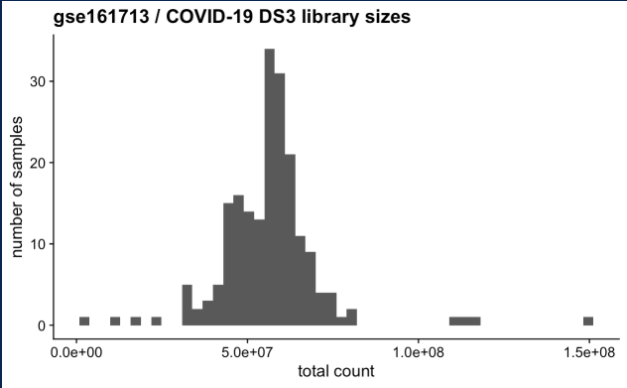
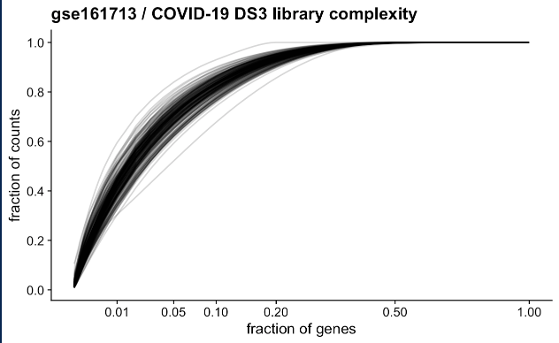
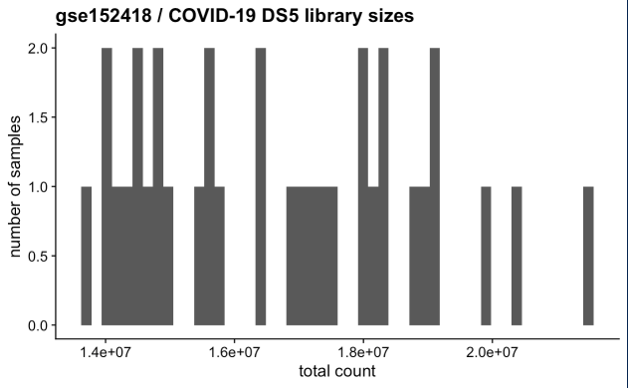
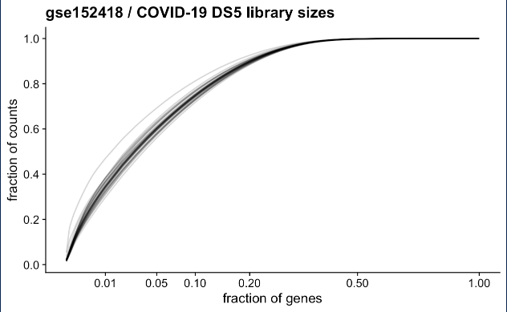
Analysis of library size distributions across the five COVID-19 datasets (GSE202805, GSE227116, GSE161713, GSE152641, and GSE152418) demonstrated high intra-dataset uniformity, with no sample presenting as a low-coverage outlier. Library complexity curves were highly consistent across all cohorts; approximately 50% of the total sequencing reads mapped to the top 5% of the most highly expressed genes, which aligns with expected transcriptomic distributions for peripheral blood and immune profiles [6, 7]. While the target sequencing depth varied visibly between studies. For example, GSE152641 maintained higher overall total counts than GSE152418, each dataset asymptotically approached a detection plateau. This indicates that despite differing baseline depths, sequencing was sufficiently saturated to reliably capture the detectable transcriptome. Furthermore, the smooth, unimodal frequency distributions suggest an absence of severe, uncorrected internal batch effects, which would typically only show at this first stage of quality control in cases of catastrophic experimental or pooling failure.
Figure1: Library Size and Complexity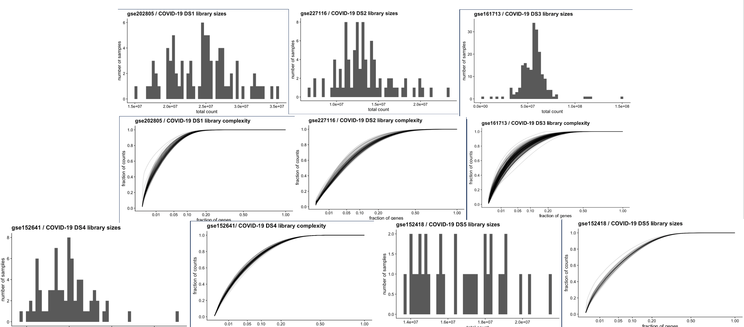
Figure 1: Sequencing quality control diagnostics across five independent COVID-19 datasets. Total library size distributions (histograms) and transcriptomic complexity curves (fraction of total counts vs. fraction of top-expressed genes) are shown for each cohort. High intra-dataset uniformity and asymptotic saturation profiles indicate sufficient sequencing depth and an absence of major technical artifacts or outlier samples prior to data integration.
Dimension Reduction
To evaluate global transcriptomic variance and assess the datasets for potential systemic technical variation or internal batch effects, we performed Principal Component Analysis (PCA) and pairwise Euclidean distance clustering on variance-stabilized count matrices across five independent datasets prior to integration and batch-correction. (Figure 2)
Exploratory analysis revealed that sample clustering was robustly driven by biological condition rather than technical covariates. In both PC space and hierarchical distance heatmaps, samples demonstrated clear, reproducible separation according to clinical status across all sharp contrast conditions (e.g., acute COVID-19 vs. healthy controls). Pairwise distance plots showed no unusual sub-clustering or distinct block-wise artifacts that indicate of hidden batch effects. Within DS2’s pairwise distance map, we see distance between the samples which is reflected within the PC plot. COVID-19 sample loadings are sparse, but there is clear separation between the healthy and disease state which is expected.
Biological conditions characterized by overlapping clinical phenotypes exhibited closer proximity in distance space. In datasets featuring recovering cohorts (GSE202805, GSE152418, and the longitudinal study GSE227116 capturing individuals > 6 months post-hospitalization), convalescent samples clustered tightly with, and were not linearly separable from, healthy controls. This proximity reflects an expected transcriptomic return toward baseline homeostasis during clinical recovery. Similarly, GSE1611713, which encompasses a broad spectrum of disease states including bacterial, influenza, acute COVID-19, and other viral respiratory infections, demonstrated continuous variance profile along PC1 and PC2. This pattern highlights the shared and distinct components of the host immune response across varying respiratory pathologies rather than technical noise. Taken together, these diagnostics confirm that biological signal remains the dominant driver of variance across all cohorts.

Figure 2: Basic Dimension Reduction of five independent respiratory transcriptomic datasets
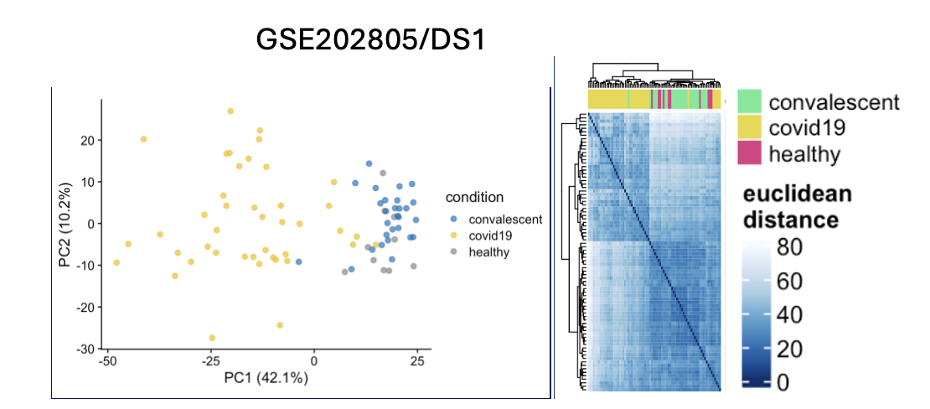 | 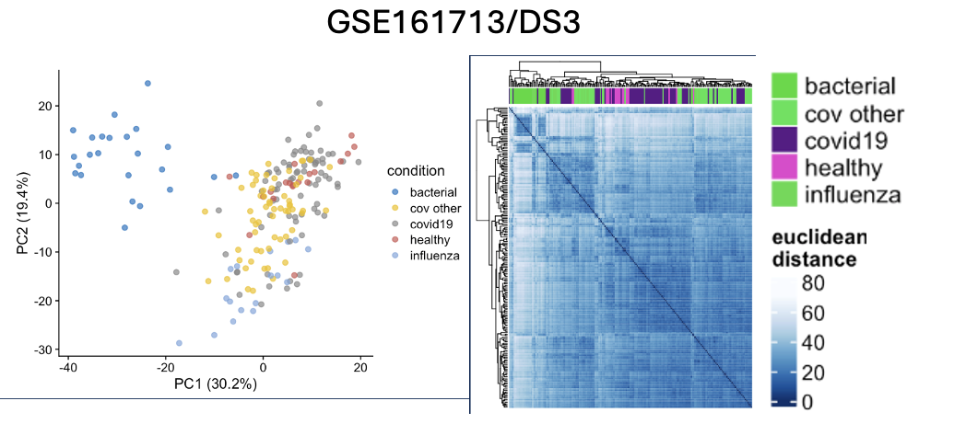
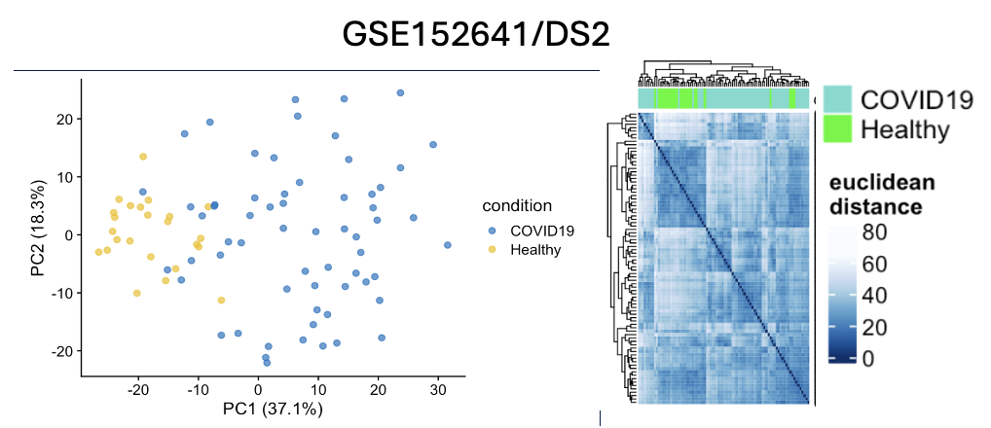 | 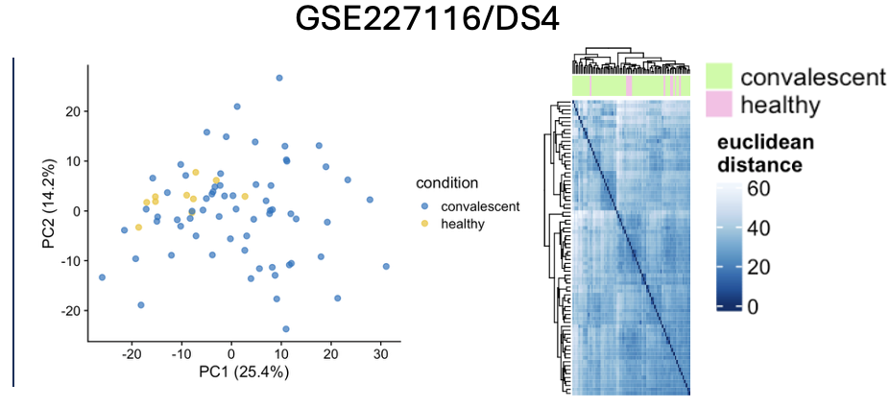
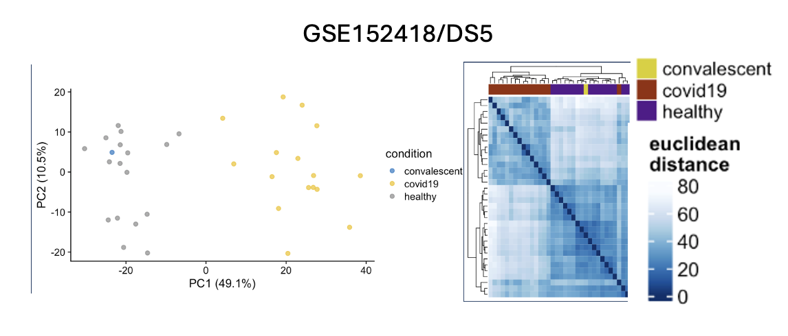

Figure 2: Basic Dimension Reduction of five independent respiratory transcriptomic datasets. For each dataset (GSE202805, GSE152641, GSE227116, GSE161713, GSE152418), sample relations are visualized via two-dimensional PCA loadings (left) and corresponding pairwise Euclidean distance heatmaps of VST counts (right).
Principal Variance Analysis Finds Sources of Technical Batch Effects
To quantitatively partition the sources of transcriptomic variance across the top ten PCs, we performed a modified PVCA utilizing only analysis of variance (ANOVA) for categorical variables and linear mixed-effects models for continuous covariates. This allowed us to find out which factor the variance within a principal component is from and the magnitude of said variance is within the PC. Which help us find if biological signal within that dataset is confounded by technical, demographic, or time-based variables.
Across the four of the five datasets (DS1, DS2, DS3, and DS5), the primary experimental variable named (condition) demonstrated the strongest statistical association with PC1. In DS3, all technical batch annotation were evaluated, the batch# covariate unexpectedly exhibited no significant association across the top ten PC despite possessing the largest number of metadata covariates. In DS5 (GSE152418), PC1 captured highly significant, overlapping associations with condition, severity, and days post symptom onset. This mirrors the expected clinical collinearity of acute viral infections, where time from onset and disease severity fundamentally dictate the magnitude of the host immune response, confirming that these variables can be robustly modeled as downstream fixed effects. Conversely DS4, (GSE227116) presented distinct variance profile where neither condition or time_point dominated the variance of PC1. Rather condition was associated with the variance of PC2. Unfortunately, I was not able to confirm within this study which covariate dominate PC1 of DS4 which could either mean there are technical batch effects, or this could be an effect of the longitudinal nature of the study where the convalescent patient’s samples are separated into 1–6-month collection intervals.
Figure 3: Heatmaps of Metadata covariate association relative to PC Variance
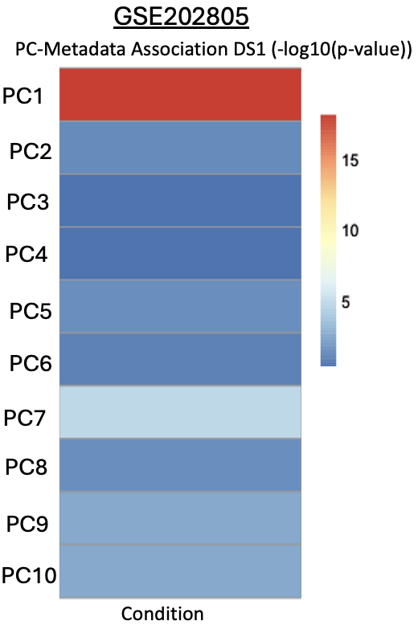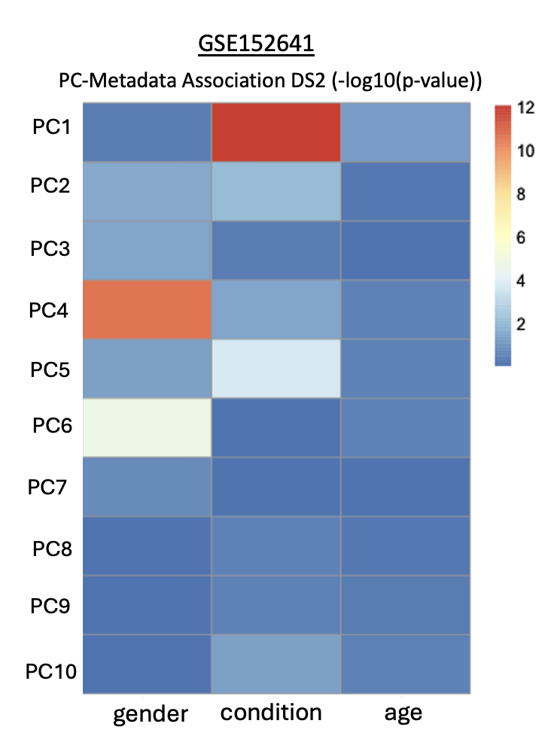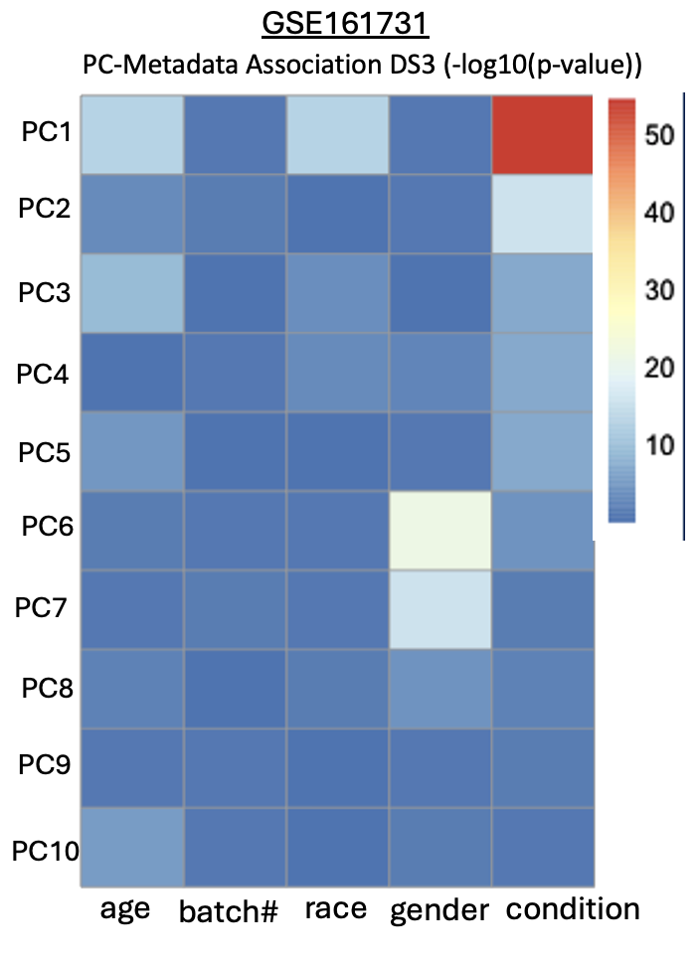
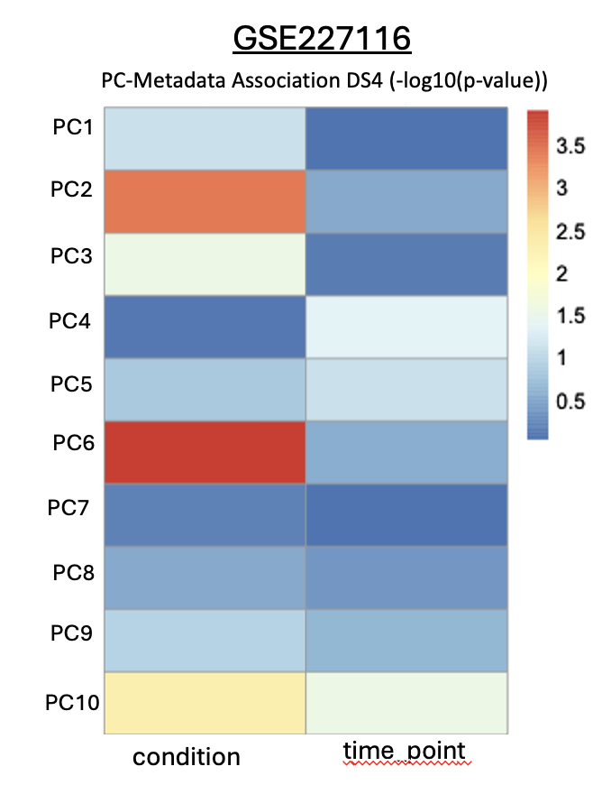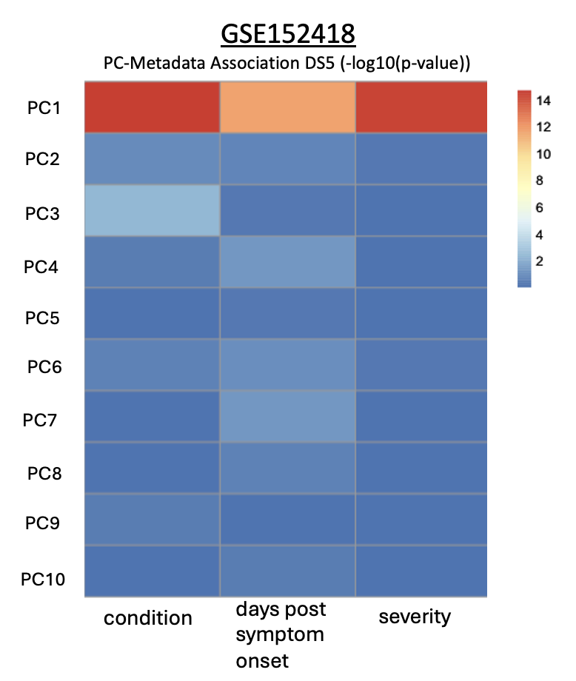
Figure 3: Heatmaps of Metadata covariate association relative to PC Variance: Statistical associations between top ten principal components and experimental, technical, or demographic covariates are visualized as heatmaps. Inherent variance partitioning is represented by significance values plotted on a -log10(p-val) scale, where warmer colors (red/orange) denote highly significant associations driving a given principal component, and cooler colors (blue) represent negligible associations. Each panel represents an independent dataset: GSE202805 (DS1), GSE152641 (DS2), GSE161731 (DS3), GSE227116 (DS4), and GSE152418 (DS5).
Integration and Batch Correction
After the Integration of the counts data and the harmonization of metadata the same dimensional reduction procedures were completed. Pre-correction show expected separation between dataset within PC and Euclidean space with clear separation between each of the datasets and sub-clustering of disease state within those separations. After batch-correction using Combat-Seq we see a clear improvement in all three diagnostic visuals. Almost all of Datasets clustered together within pairwise distance and PC space and the variance within the dataset origin is more associate with PC2 instead of PC1 and the condition now dominantly associated within PC1. However, not all the datasets harmoniously cluster together. Post-correction, the integrated landscape resolved into two distinct, linearly separable macro-clusters (DS1/DS2 vs. DS3/DS4/DS5). Because this macro-level split persists across both pre- and post-correction spaces and cuts across mixed sequencing platforms, it indicates a fundamental biological or experimental design divergence—such as tissue-source differences rather than technical noise. Technical batch effects such as sequencing platform, study design, and library preparation method or even tissue are not features of separation of the macro-clusters (Table1). Additionally, within these macro-clusters, samples organize along a clean biological gradient of respiratory disease status. In summary, these integration diagnostics demonstrate that technical batch effects were successfully minimized, ensuring that downstream differential expression modeling can reliably isolate universally conserved disease biomarkers.
Pre-Batch Corrected Integrated Dataset (Figure 4A)
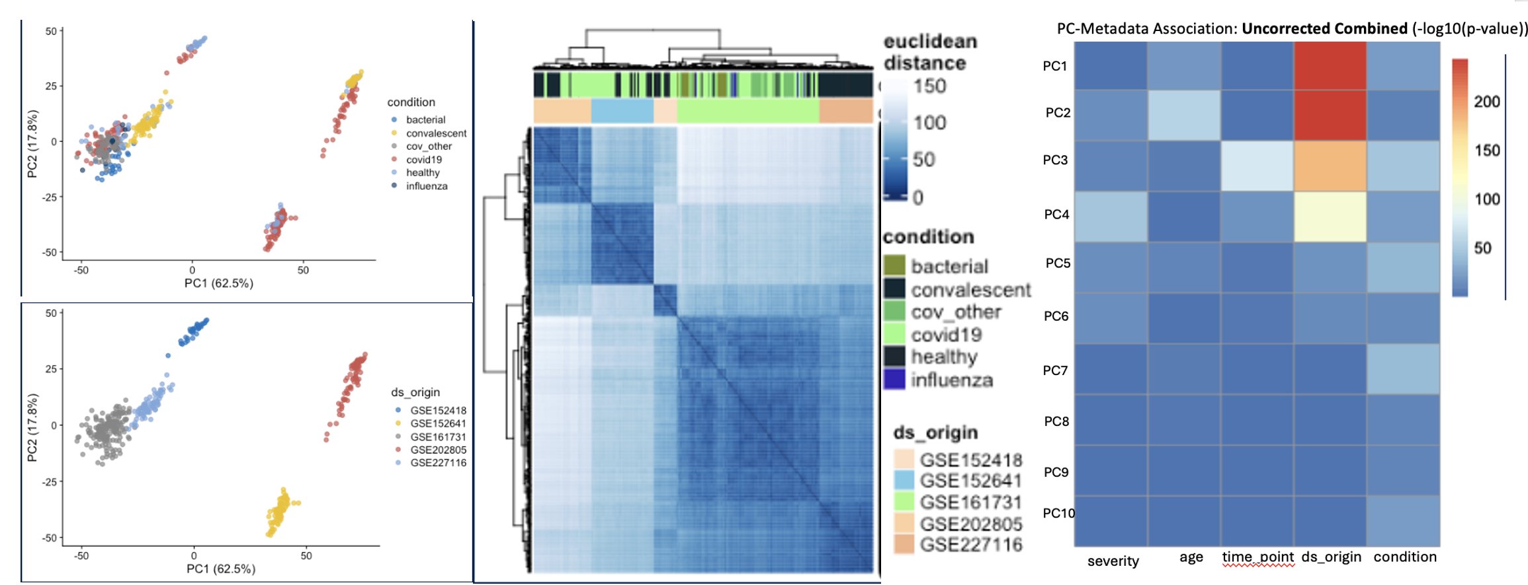
4C
4B
4A
Post-Batch Corrected Integrated Dataset (Figure 4B)
4D
4E
4F
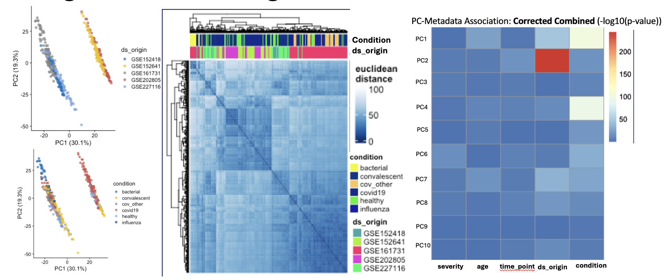
Figure 4: Dimensionality reduction and variance partitioning diagnostics of the integrated dataset before and after batch correction. Top Panels: Pre-correction: Global transcriptomic profiles prior to normalization, showcasing systemic technical variation. (4A) Principal Component Analysis (PCA) score plots colored by clinical condition (top) and dataset origin (bottom). (4B) Hierarchical clustering heatmap of pairwise Euclidean distances between samples. (4C) PVCA heatmap showing covariate associations -log10(pvalue) across the top ten principal components. Bottom Panels: Post-correction: Evaluation of the dataset following ComBat-Seq harmonization. (4D) Post-correction PCA score plots colored by dataset origin (top) and clinical condition (bottom). (4E) Post-correction sample-to-sample Euclidean distance heatmap. (4F) Post-correction PVCA heatmap mapping residual covariate variance contributions.
DEGs Across The Six Datasets
Among the 5 datasets, including the 6th integrated one (dsint), there are only 15 possible pairwise combinations from the six disease states, including the healthy control state (table2). The Integrated dataset would hold most of those possible comparisons results after DEGs analysis and would hold most of the DEGs, thus it was excluded when comparing the overall shared DEGs regardless of direction (Upregulated/Downregulated) or comparison among all the datasets(Figure XB). From the 5-way overlap comparing shared DEG volume we can see that there 0 universal DEGs among the 5 publicly available datasets. However, there are 60 DEGs that are shared among by at least 4 datasets. These are likely housekeeping genes that are downregulated from healthy to a disease state. There is also large population of DEGs that mutually exclusive to their own datasets. The lack of universal DEG homogeneity among the total overlap of all datasets does not indicate a major technical discontinuity among those experiments to conclude irreproducibility, but a lack of comparative specificity across the resulting meta-data (#DEGs after analysis). Comparing only the DEG overlap among datasets that contain specific comparison would better suite the question of “irreproducibility” between datasets. The second venn diagram shows the overlap between the datasets over-represented terms regardless of direction and comparison within the DEGs. The 15 universally shared are all non-specific, non-repository disease related terms such as “regulation of mitotic nuclear division”, and “negative regulation of organelle organization”. These generic terms do not give any positive or negative biological indicator after DEG analysis only that biological processes are occurring. To robustly test for cross-dataset reproducibility, future iterations should restrict validation frameworks exclusively to datasets sharing identical clinical contrast. This would mean comparing the number of overlapping DEGs and ORAs within the healthy vs covid-19 comparison among the datasets.
Figure 5: Total DEG and ORA Comparison
Number of DEGs per Comparison split by Dataset
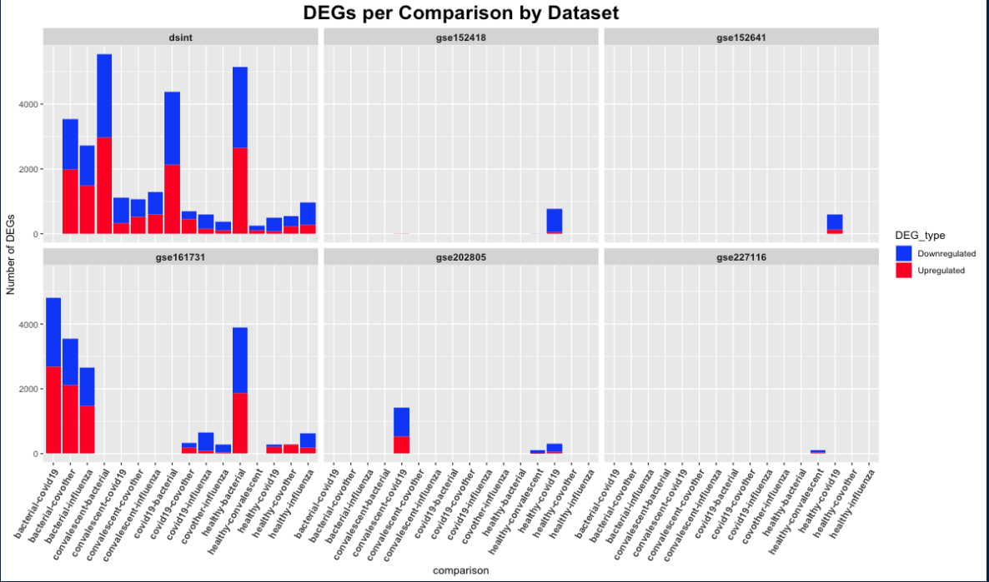
Total DEG Venn Diagram | Total ORA Term Venn Diagram
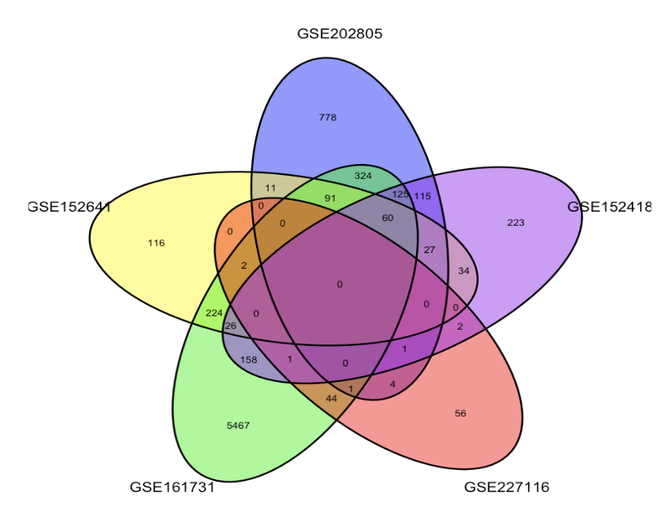 | 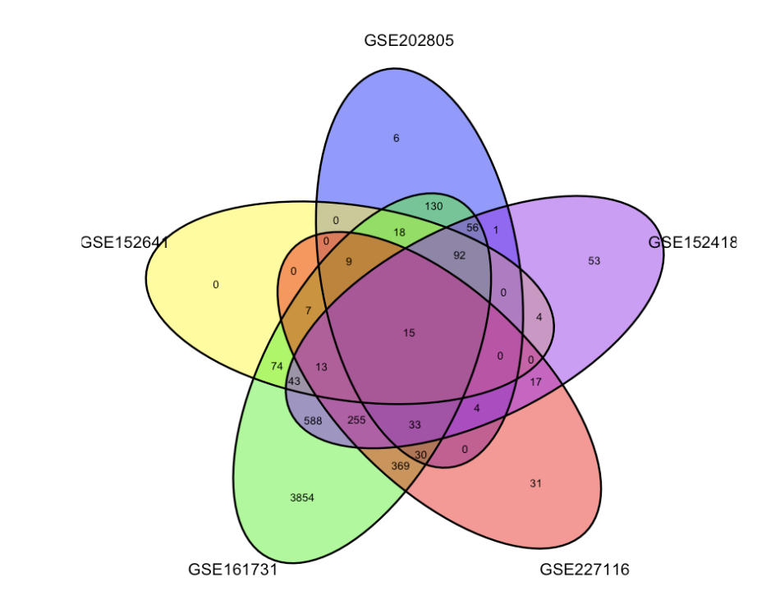
Figure 5: Overlap and distribution of differentially expressed genes (DEGs) and over-represented pathway terms across datasets. Top Panel: Stacked bar plots illustrating the total number of statistically significant upregulated (red) and downregulated (blue) DEGs identified across individual clinical comparisons, faceted by independent dataset and the merged integrated dataset. Bottom Left: A 5-way Venn diagram displaying the intersection of unique DEGs identified across the individual cohorts, showing a lack of universally shared individual gene identifiers (0 genes at the central intersection). Bottom Right: A 5-way Venn diagram evaluating the intersection of enriched Gene Ontology: Biological Process (GO:BP) terms derived from over-representation analysis (ORA), highlighting a core consensus of 15 universally shared biological pathways.

Consolidating the DEG overlap with datasets that only contain them healthy-covid-19 DEGs will help to determine any specific biomarkers or consistent over-represented terms for this comparison and at least one point reproducibility. The Upset plots show that majority of DEGs are downregulated (log2fc < -1) in the healthy samples among all datasets that contain the healthy-covid-19 contrast and contains most of the overlaps among the datasets. The direction agnostic Venn Diagram shows that a lot of the DEGs belong to mutually exclusive groups which may indicated different biological phases of covid-19 relative to the healthy control samples within those datasets. The 12 shared DEGs are plotted within the heatmap. Each of these downregulated DEGs encode proteins that are directly or indirectly involved with cell cycle regulation. For example, CDC20 encodes the a “substrate specific adapter for the anaphase-promoting complex” and BUB1, which encodes a protein that is essential for spindle assembly checkpoint. These types of downregulated DEGs are what likely contribute to the high number of over-represented terms such as “mitotic nuclear division”, “chromosome segregation”, “mitotic sister chromatid segregation”, and “regulation of chromosome segregation”. However, multiple datasets’ ORA results from the healthy-covd19 contrast hold statistically significant terms with many downregulated DEGs (10-50) such “immune response”, “B cell mediate immunity”, and “defense to virus”. The Downregulated DEGs under these OR terms from the gene ontology dataset (GODB) were overlapped using an Upset plot (Figure 7F) were only 2 total downregulated DEGs were presented in the immunological related terms across 4 out of the 5 datasets that have the healthy-covid19 contrast (7F) [IGH1, and IGH3]. The Immunoglobulin Heavy Constant Gamma markers 1 and 3 helps to connect circulating antibodies in the extracellular region with downstream immune effector mechanisms. Given the dimension reduction from figure 4 it’s likely all the datasets do indeed contain positive COVID-19 samples, but the inconsistent downregulated DEGs among these datasets hint at inconsistent immunological or disease stages of the same disease within the samples between datasets.
Figure 6: Consolidating Healthy-Covid19 Comparison Results
Upset Plot of All Upregulated DEGs (health vs covid19) (6A) | Upset Plot of All Downregulated DEGs (health vs covid19) (6B)
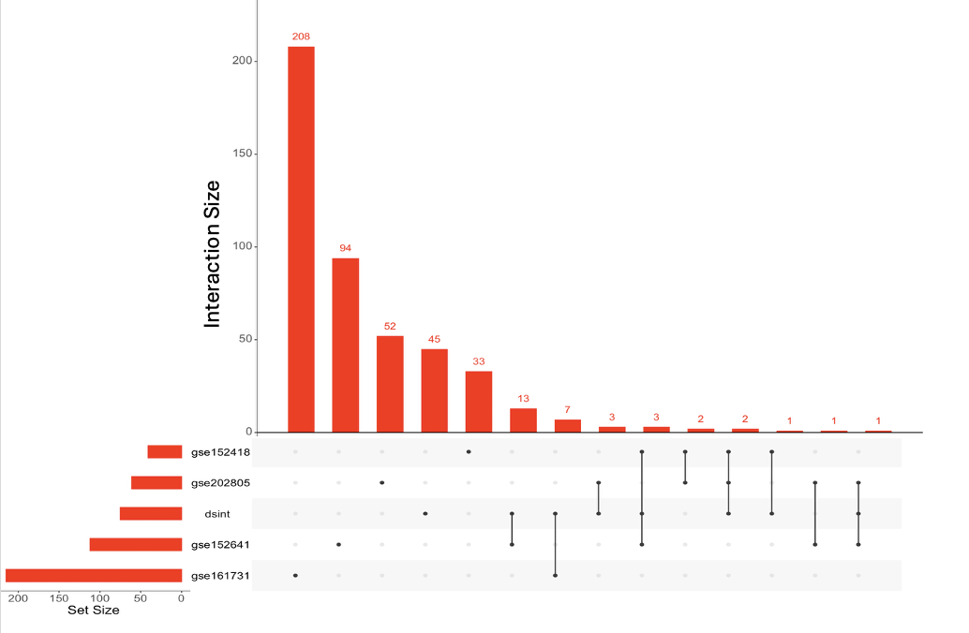 | 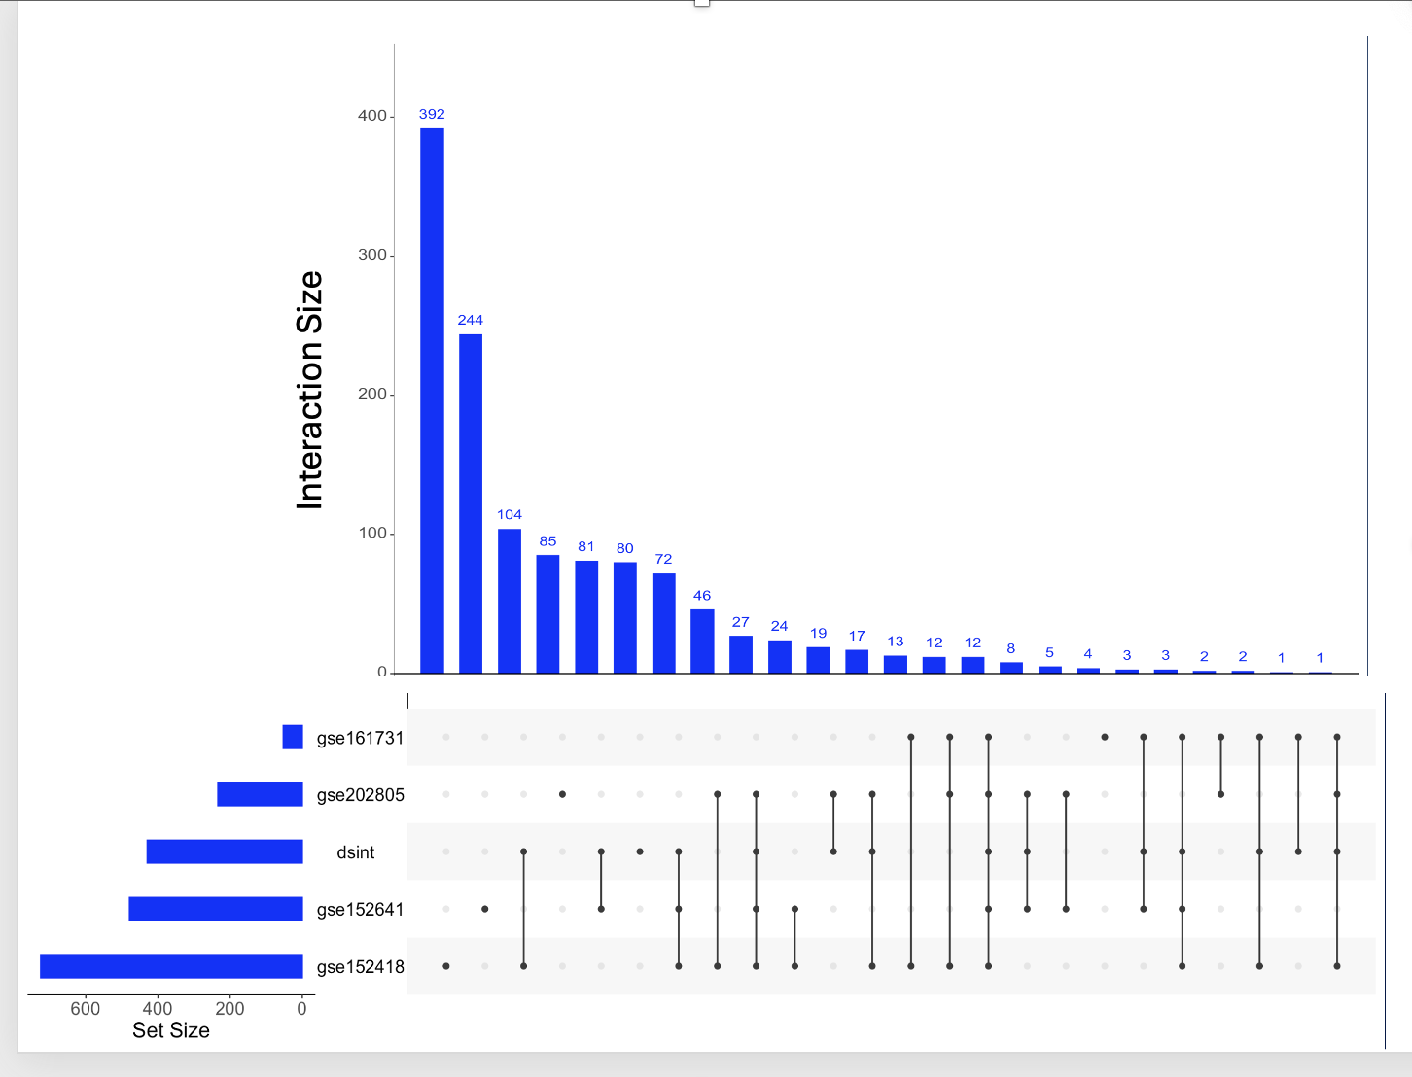
Venn Diagram of All DEGs from Healthy vs Covid-19 contrasts only (6C) | HeatMap of DEGs within Interesct (healthy vs covid-19) (6D)
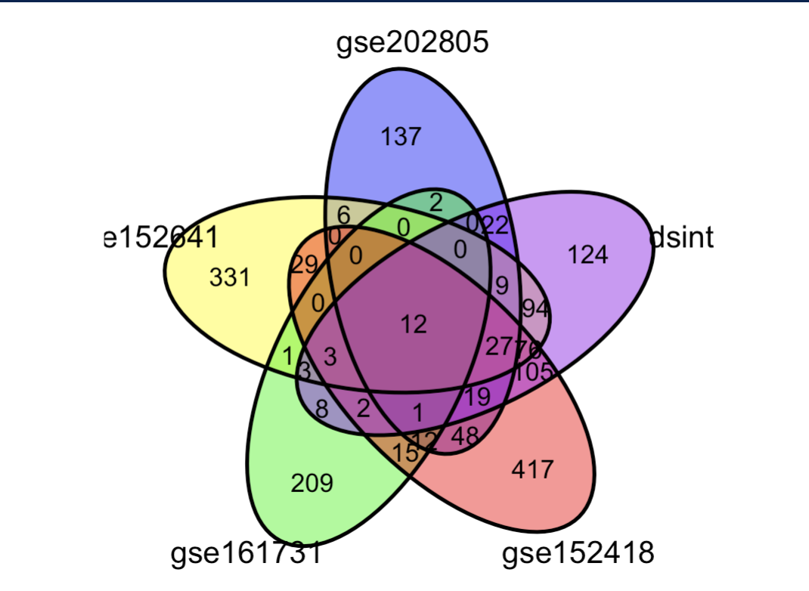 | 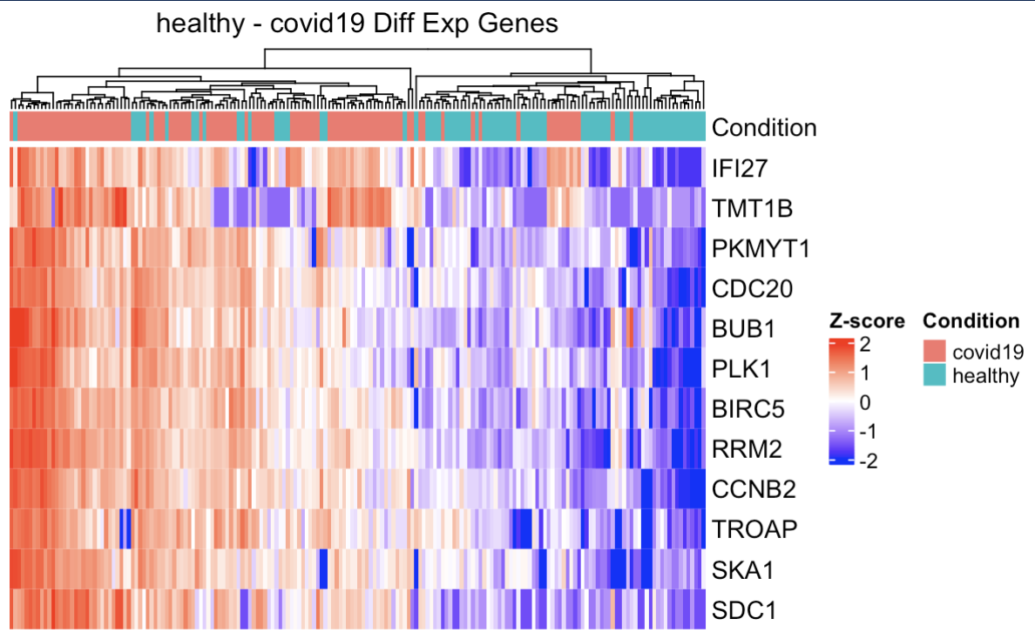
Figure 6: Consolidated differential expression landscape restricted to Healthy vs. Acute COVID-19 contrasts. Top Left (6A): UpSet plot displaying the intersection sizes and set configurations for significantly upregulated DEGs (orange) across individual cohorts and the integrated dataset (dsint). Top Right (6B): UpSet plot illustrating the intersection sizes and specific dataset overlaps for significantly downregulated DEGs (blue). Bottom Left (6C): Direction-agnostic 5-way Venn diagram tracking total shared and mutually exclusive DEGs specifically isolated from the Healthy vs. Acute COVID-19 clinical comparison. Bottom Right (6D): Hierarchical clustering heatmap of $z$-score scaled expression values for the core consensus DEGs identified at the central intersection, annotated by clinical status (COVID-19 vs. Healthy).
Figure 7: Healthy-Covid19 OR Terms per Dataset
GSE202805 – Downregulated OR (Figure 7A) | GSE152641 – DownRegulated Ors (Figure 7B)
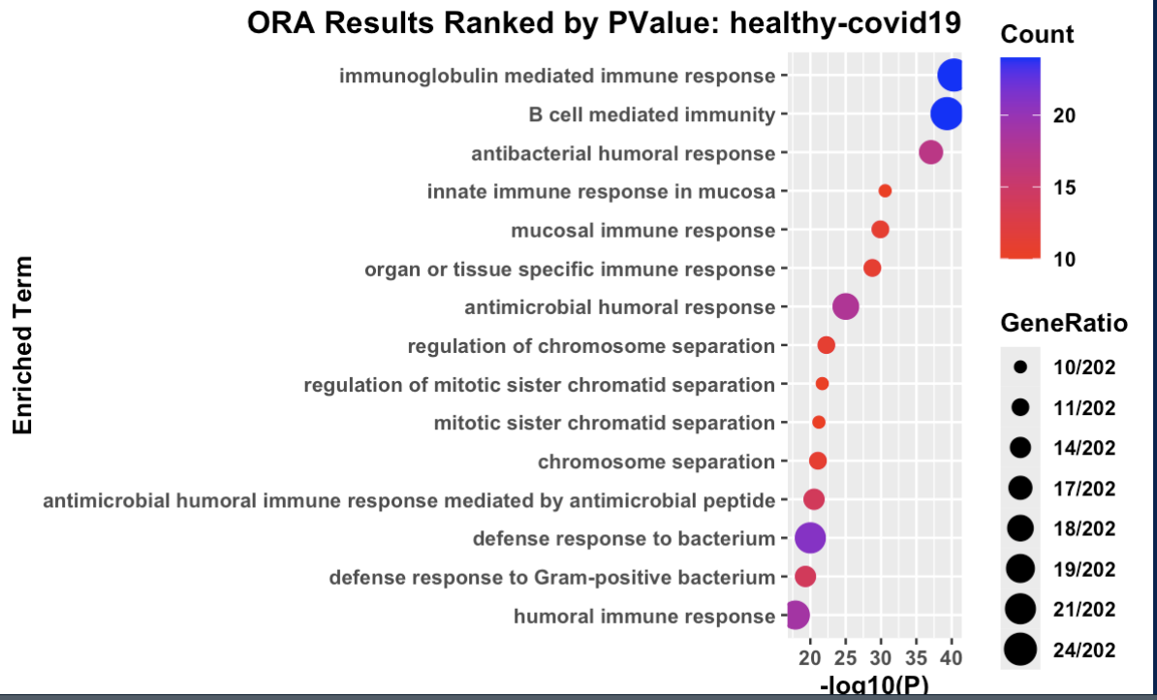 | 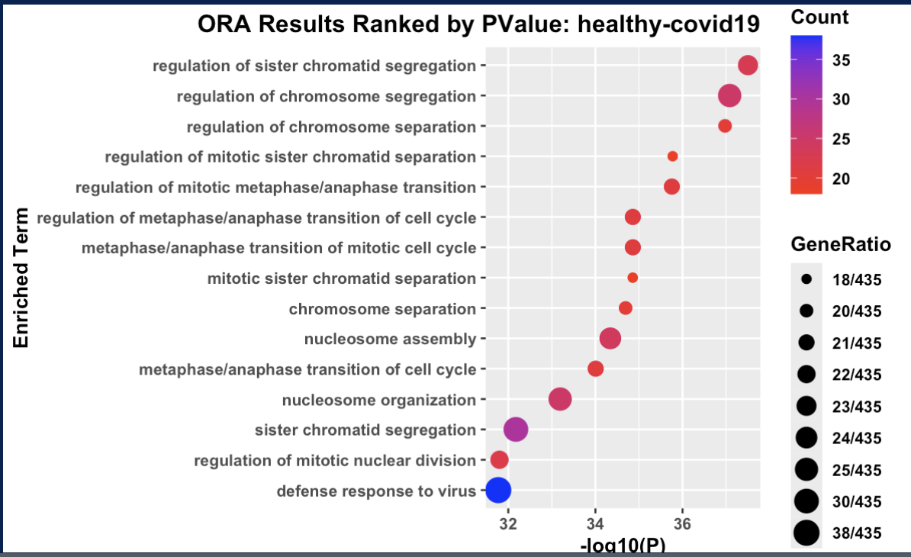
GSE152418 – Downregulated Ors (7C) | DS_INT- Downregulated Ors (7D)
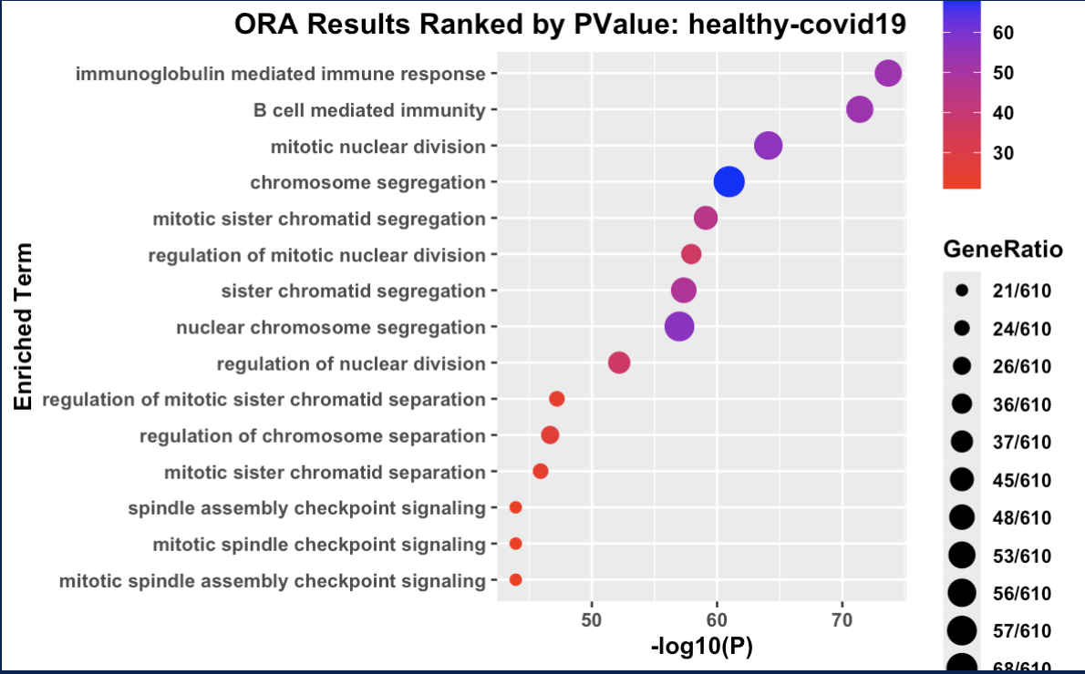 | 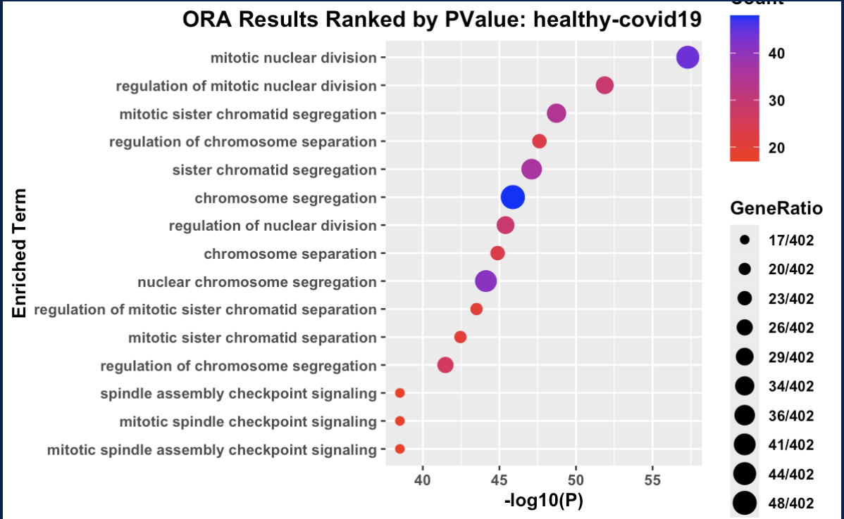
GSE161731 Downregulated Ors (7E) | UpsetPlot of Downregulated DEGs from Disease Related ORAs (7F)
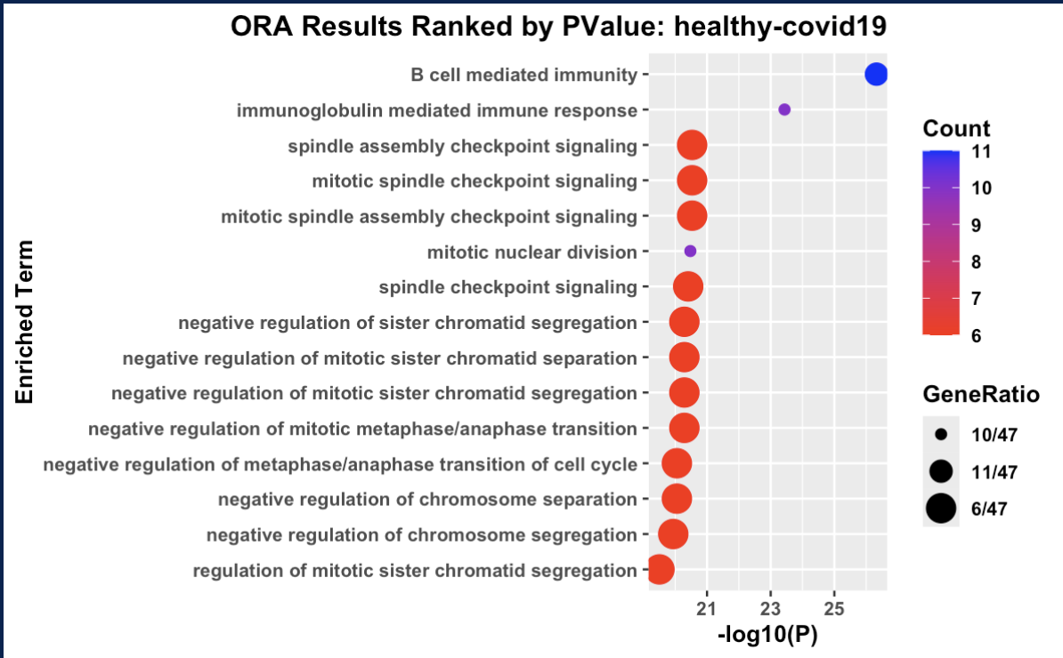 | 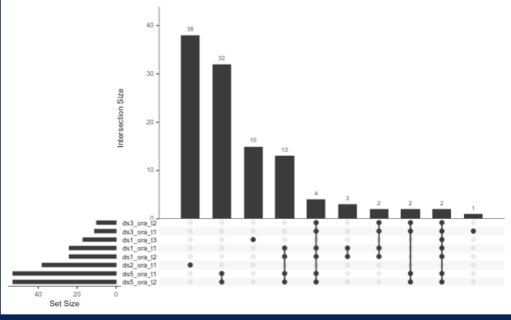

Figure 7: Over-Representation Analysis (ORA) and gene overlap of downregulated pathways in the Healthy vs. Acute COVID-19 contrast. * Panels (7A–7E) Dotplots of Enriched Terms: Over-representation analysis results against the Gene Ontology: Biological Process (GO:BP) database for downregulated DEGs, ordered by statistical significance -log10(pval). Panels represent independent cohorts GSE202805 (7A), GSE152641 (7B), GSE152418 (7C), GSE161731 (7E), and the integrated dataset DS_INT (7D). Dot size corresponds to the absolute number of DEGs enriched within a specific term (Count), while the color gradient indicates the statistical significance. The GeneRatio represents the proportion of input differentially expressed genes that map to a given pathway relative to the total number of DEGs successfully annotated within the entire GO reference database. Bottom Right Panel (7F) Intersection of Pathway DEGs: An UpSet plot showing the overlap of specific downregulated genes extracted across disease-related immunological and cellular stress pathways across the studies. Multi-set intersections highlight the precise commonality between datasets.
Discussion
Bulk-RNA-Seq reproducibility is a complex topic. It involves taking into consideration the study design, and possible latent variables within each study to show that there is indeed large enough continuity between publicly available datasets for larger studies. Each dataset had consistent library quality and complexity allows for a detectable transcriptome across each datasets for consistent and reliable feature space. Even with the addition of batch correction of count data (Figure 4B), it does not guarantee that there would be congruent biological signals (Figure 4D). In my example, even after using Combat-Seq, I was unable to rectify batch effects between the macro-clusters (4D). I was only able to confirm that each of datasets that compared the COVID-19 samples across most datasets are biologically within an active immunological state relative to the healthy samples. This is corroborated by the upregulated DEGs from integrated dataset’s ORA which showed terms such as “T cell differentiation” with only 7 upregulated DEGs (CD69, CD83, IFNG, IF1A, IL23R, NRARP, TNFSF9) each of which is an upstream differentiation. The macro-split between DS1/DS2 and DS3/4/5 could not be cause by the separation between datasets the tissue originates from peripheral blood monocular cells (PBMC) and whole blood tissue because those macro-clusters consist of both. This heterogeneity is also true for platform consistency as well. It’s likely that Combat-Seq cannot consider for the study design type or the disease state phases between datasets.
The lack of ubiquitous DEGs is due to non-specific comparison of contrasts. However, it did highlight the many DEGs that shared among all the datasets that are associated with housekeeping functions such as cell cycle regulation and mitotic separation mechanism which helps to explain the generic over-represented terms that signify cellular stress and turnover rather than specific virus signature. The two consistently downregulated DEGs across the 4 datasets that were found signal the start of B lymphocyte differentiation into Ig-secreting plasma cells. The downstream effect leads to pathogen neutralization (McHeyzer-Williams M, et. al., 2011). These immunological signals were most heavily concentrated in dataset 1 (GSE202805), dataset 2 (GSE154268), and the integrated dataset’s healthy-covid19 contrast. The immunological differences may contribute to the macro-separation within PC space after batch correction. This would warrant further investigation into specific DEGs that are directly associated with immune cell activation, and differentiation within COVID-19. Additionally, reproducibility between has not been fully shown. However, there is insufficient number of consistent comparisons across the datasets to claim consistent difference. Additionally, with the now known biological gradient between multiple different datasets a new batch correction algorithm would be necessary to correct for this.

- Cui, W., Xue, H., Wei, L. et al. High heterogeneity undermines generalization of differential expression results in RNA-Seq analysis. Hum Genomics 15, 7 (2021). https://doi.org/10.1186/s40246-021-00308-5
- Yu Y, Mai Y, Zheng Y, Shi L. Assessing and mitigating batch effects in large-scale omics studies. Genome Biol. 2024 Oct 3;25(1):254. doi: 10.1186/s13059-024-03401-9. PMID: 39363244; PMCID: PMC11447944.
- Li, J., Bushel, P., Chu, T., Wolfinger, R., Batch Effects and Noise in Microarray Experiment, Chapter 12, 2010
- Robinson MD, McCarthy DJ, Smyth GK. edgeR: a Bioconductor package for differential expression analysis of digital gene expression data. Bioinformatics. 2010 Jan 1;26(1):139-40. doi: 10.1093/bioinformatics/btp616. Epub 2009 Nov 11. PMID: 19910308; PMCID: PMC2796818.
- Yu G, Wang LG, Han Y, He QY. clusterProfiler: an R package for comparing biological themes among gene clusters. OMICS. 2012 May;16(5):284-7. doi: 10.1089/omi.2011.0118. Epub 2012 Mar 28. PMID: 22455463; PMCID: PMC3339379.
- Mastrokolias, A. et al. (2012): “Globin mRNA reduction for whole blood transcriptome sequencing.” Frontiers in Genetics.
- Monaco, G. et al. (2019): “RNA-Seq Profiling of Leukocyte Subsets in Human Peripheral Blood.” Cell Reports.
- McHeyzer-Williams M, Okitsu S, Wang N, McHeyzer-Williams L. Molecular programming of B cell memory. Nat Rev Immunol. 2011 Dec 9;12(1):24-34. doi: 10.1038/nri3128. PMID: 22158414; PMCID: PMC3947622.

